ANA-050 Functional Specification
Simpsons Beverages: Auto-populate density value in PDS002/E based on UOM conversion

Document Properties
Authors | Eshan Fernando | Infor M3 Consultant

 | Bevon Raj | Senior Consultant/ Project Manager | Date: 11/08/2026

Change Control | Eshan Fernando | Creation | Date: 11/08/2026
Change Control | Eshan Fernando | Adjustment to quantity conversion based on basic UOM | 13/10/2026

Contents
ANA-050 Functional Specification 1
Document Properties 1
Contents 1
Introduction 2
Functional Overview 2
Current process 2
Proposed process 2
Below is the sequence in which APIs are to be executed. 3
Error Handling 4
Assumptions & Limitations 5

Introduction
This ANA-050 Functional Specification provides a functional solution for the Auto-populate density value in PDS002/E based on UOM conversion requested by Simpsons Beverages.
It is not intended to provide technical information. Any supporting technical information can be found in the accompanying ‘TAR-040 Technical Specification’ document, if provided.

The primary objective of this specification is to provide a functional overview of a solution to the proposed modification.

It does not consist of any training material that explains to a detailed level how the deliverables form the functional solution. It is expected that the reader of this document is to have a good understanding of any Infor M3 programs mentioned within this specification.

Functional Overview

Current process
From an Infor M3 master data perspective, Simpsons will need to spend a significant amount of time manually updating recipe consumption values to reflect density across IBC recipes, both during the initial data load and when new IBC codes are created.
This activity does not add value to Simpsons, as density information is already maintained within PLM and transferred to M3 when a recipe is approved. As a result, the manual adjustment of recipe consumption values based on density creates unnecessary effort, introduces the risk of errors, and duplicates data maintenance activities across systems.

Proposed process
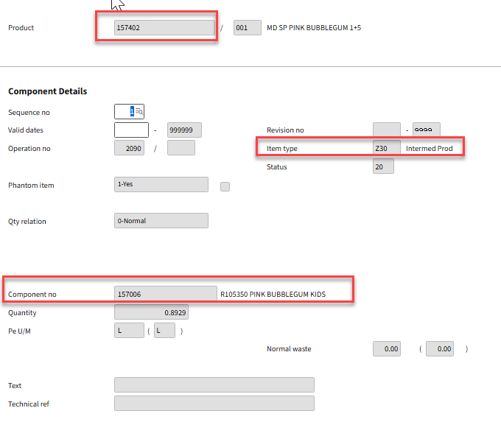
Figure 1: User adds the recipe to the IBC structure
To reduce the effort associated with data conversion, an H5 script is used in PDS002/E (MPDMAT table) to automatically populate the Quantity (CNQT) field when the recipe/ component (PMMTNO) item type (MMITTY) is 'Z30' and the product (PMPRNO) item type (MMITTY) is 'Z11'.
The functionality operates as follows: when the PDS002/E (MPDMAT table) panel is loaded, the H5 script checks whether the recipe/ component (PMMTNO) item type is 'Z30'. If this condition is met, the script retrieves the item type of the product (PMPRNO). If the product item type is 'Z11', the script calculates the equivalent recipe quantity in Liters based on a recipe quantity expressed in a KG, using the relevant density. The calculated value is then automatically populated in the Quantity (CNQT) field.

Below is the sequence in which APIs are to be executed.

Step 01: Retrieve the item type against the product code.
  - API: MMS200MI
  - Transaction: Get
Description | Field | Test Value | Extraction Method
Item Number | ITNO | 157402 | PMPRNO (Product number) in PDS002/E (MPDMAT table)
Table 1: Inputs to retrieve the item type against the IBC code
Based on inputs to Table 1, below outputs are obtained.

Description | Field | Test Value
Item type | ITTY | Z11
Unit of Measure | UNMS | KG
Table 2: Item type for the IBC code
If output retrieved from Table 2 is ‘Z11’ continue to Step 02 or Step 03, else stop the process.

Step 02: UNMS retrieved from Table 2 is KG

Step 02.01: Calculate the recipe consumption in Liters.
  - API: MMS015MI
  - Transaction: Convert
Description | Field | Test Value | Extraction Method
Item Number | ITNO | 157006 | PMMTNO (Recipe/ Component number) in PDS002/E (MPDMAT table)
Quantity | ORQT | 1 | Hardcoded value
From U/M | UNM1 | KG | Hardcode to KG
To U/M | UNM2 | L | Hardcode to L
Table 3: KG to L conversion for the recipe code
Based on inputs to Table 3, below outputs are obtained.

Description | Field | Test Value
Calculated quantity | ORQT | 0.8928
Table 4: Retrieve the quantity in Liters for a consumption quantity of a KG

Step 02.02: Update quantity against the recipe/ component.
  - API: PDS002MI
  - Transaction: UpdateComponent
Description | Field | Test Value | Extraction Method
Facility | FACI | SB1 | Hardcoded
Product | PRNO | 157402 | PMPRNO in PDS002/E (MPDMAT table)
Structure Type | STRT | 001 | PMSTRT in PDS002/E (MPDMAT table)
Sequence number | MSEQ | 1 | PMMSEQ in PDS002/E (MPDMAT table)
Quantity | CNQT | 0.8928 | Calculated quantity in Table 4
Table 5: Update recipe consumption based on KG to L conversion

Step 03: UNMS retrieved from Table 2 is L

Step 03.01: Update quantity against the recipe/ component.
  - API: PDS002MI
  - Transaction: UpdateComponent
Description | Field | Test Value | Extraction Method
Facility | FACI | SB1 | Hardcoded
Product | PRNO | 157402 | PMPRNO in PDS002/E (MPDMAT table)
Structure Type | STRT | 001 | PMSTRT in PDS002/E (MPDMAT table)
Sequence number | MSEQ | 1 | PMMSEQ in PDS002/E (MPDMAT table)
Quantity | CNQT | 1 | Hardcoded
Table 6: Update recipe consumption based on consumption per Liter
Once the user returns to PDS002/U1, the Quantity/Run Time values within the recipe must be sense checked to ensure they have been calculated correctly and accurately reflect density. If the Quantity/Run Time values do not reflect the expected density-based conversion, the issue should be raised with Anthesis for further investigation.

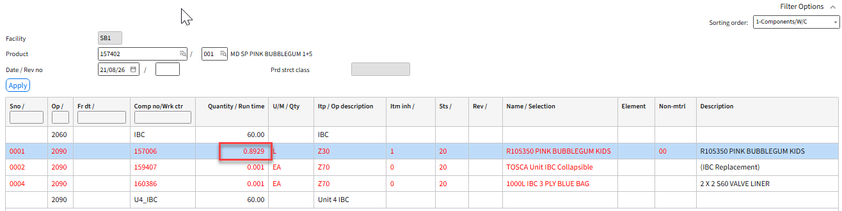

Figure 2: PDS002/U1 Recipe consumption highlighted for the IBC code

Error Handling
Once the user returns to PDS002/U1, if Quantity/ Run time against the recipe doesn’t reflect density, it needs to be flagged with Anthesis for investigation.

Assumptions & Limitations
- Density (KGs per L) for the recipe/ component has been transferred from PLM and is updated in MMS015 as a unit of measure conversion between KGs to Ls.
- The recipe/ component is in approved status (20-Released) in Item/ Master (MMS001) and Item/ Warehouse (MMS002) programs.
- The script should only function upon PDS002/E form load and when adding a recipe/ component (Item Type: Z30) to an IBC (Item type: Z11) structure.

